NOISY CHANNELS
Noisy means the data may be corrupted or lost.
In Noisy Channels we need to implement both Flow control and Error Control Mechanisms in the Protocols.

Stop-and-Wait Automatic Repeat Request (ARQ)
This Protocol uses Acknowledgements and Sequence Numbers to implement Flow and Error Control mechanisms. The corrupted and lost frames need to be resent in this protocol.
There are 2 Questions arises:

If the receiver does not respond when there is an error, how the sender knows which frame to resend?
Solution: The sender keeps a copy of the sent frame. At the same time, it starts a timer.
If the timer expires and there is no ACK for the sent frame then “3 actions” to be performed
  - The frame is resent
  - The copy is held
  - The timer is restarted.
Note: Since the protocol uses the stop-and-wait mechanism, there is only one specific frame that needs an ACK even though several copies of the same frame can be in the network.

What if an ACK frame is also lost?

Solution:
Since an ACK frame can also be corrupted and lost, it needs a Sequence Number and Redundancy Bits.
The ACK frame for this protocol has a sequence number field.
In this protocol, the sender simply discards a corrupted ACK frame or ignores an out-of-order one.

Sequence Numbers
- Sequence Number is the number that is given to the data frame.
- A field is added to the data frame to hold the sequence number of that frame.
- The sequence numbers are based on modulo-2 arithmetic.
Range: Consider the field is m bits long, the range of sequence numbers are from 0 to 2^{m}-1, and then the same number are repeated.

Acknowledgment Numbers
The acknowledgment numbers always announce the sequence number of the next frame expected by the receiver.
Example:
- If frame 0 has arrived safe and sound, the receiver sends an ACK frame with acknowledgment 1 (meaning frame 1 is expected next).
- If frame 1 has arrived safe and sound, the receiver sends an ACK frame with acknowledgment 0 (meaning frame 0 is expected).

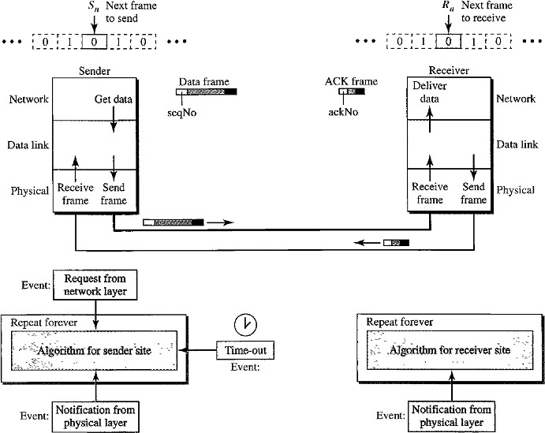
Design

- The sending device keeps a copy of the last frame transmitted until it receives an acknowledgment for that frame.
- The design contains:
  - seqNo: Sequecne Number
  - ackNo: Acknowledgement Number
  - S_{n}: Sender Control variable- that holds the sequence number for the next frame to be sent (0 or 1).
  - R_{n}: Receiver Control Variable- that holds the number of the next frame expected.
- When a frame is sent, the value of S_{n} is incremented (modulo-2), which means if it is 0, it becomes 1 and vice versa.
- When a frame is received, the value of R_{n} is incremented (modulo-2), which means if it is 0, it becomes 1 and vice versa.
- S_{n} variable points to the slot that matches the sequence number of the frame that has been sent, but not acknowledged.
- Sequence numbers are modulo-2, the possible numbers are 0,1,0,1,0,1,……and so on.
- R_{n} points to the slot that matches the sequence number of the expected frame.
- Three events can happen at the sender site; one event can happen at the receiver site.

There are 3 Events can happen at Sender site.
- RequestToSend (which comes from network layer to data link layer)
- ArrivalNotification (which comes from physical layer to data link layer)
- TimeOut

Event 1: Request to send
- Event RequestToSend is used to send the frame to receiver.
- Before the frame is sent, it is stored in the buffer. We need at least one buffer to hold this frame until sender make sure that it is received safe and sound.
- The copy is used for resending a corrupt or lost frame.
- Sender has to prevent the network layer from making a request before the previous frame is received safe and sound.

Event 2: Arrival Notification
- If the frame is not corrupted then three actions will be done:
  - The ackNo of the ACK frame matches the sequence number of the next frame to send.
  - Timer is stopped
  - Purge the copy of the data frame that was saved.
- If the frame is corrupted then it ignore arrival notification event and wait for the next event to happen.

Event 3: Time Out
- After each frame is sent, a timer is started.
- When the timer expires the frame is resent and the timer is restarted.

Receiver-site:
Only One Event happens at the receiver site.
- First, all arrived data frames that are corrupted are ignored.
- If the seqNo of the frame is the one that is expected (R_{n}), the frame is accepted, the data are delivered to the network layer, and the value of R_{n} is incremented.

Note:
- Even if the sequence number of the data frame does not match the next frame expected, an ACK is sent to the sender.
- This ACK reconfirms the previous ACK instead of confirming the frame received.
- This is done because the receiver assumes that the previous ACK might have been lost; the receiver is sending a duplicate frame.
- The resent ACK may solve the problem before the time-out does it.

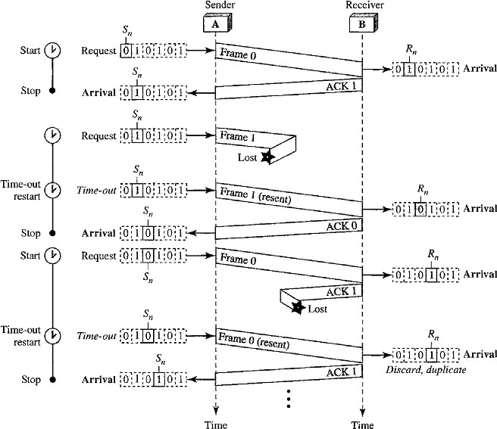
Flow diagram
- Frame 0 is sent and acknowledged.
- Frame 1 is lost and resent after the time-out.
- The resent frame 1 is acknowledged and the timer stops.
- Frame 0 is sent and acknowledged, but the acknowledgment is lost.
- The sender has no idea if the frame or the acknowledgment is lost, so after the time-out, it resends frame 0, which is acknowledged.

Pipelining
- In networking a task is often begun before the previous task has ended. This is known as pipelining.
- There is no pipelining in Stop-and-Wait ARQ because sender need to wait for a frame to reach the destination and be acknowledged before the next frame can be sent.
- Go-Back-N ARQ and Selective Repeat ARQ use Pipelining, because several frames can be sent before sender receives the ACK about previous frame.
- Pipelining improves the efficiency of the transmission if the number of bits in transition is large with respect to the bandwidth-delay product.

Go-Back-N Automatic Repeat Request (ARQ)
In this protocol
- Sender can send several frames before receiving acknowledgments.
- Sender keep a copy of these frames until the acknowledgments arrive.

Design of Go-Back-N ARQ
The idea is similar to Stop-and-Wait ARQ, multiple frames can be in transit in the forward direction, and multiple acknowledgments in the reverse direction.
The difference is that the send window allows us to have as many frames in transition as there are slots in the send window.
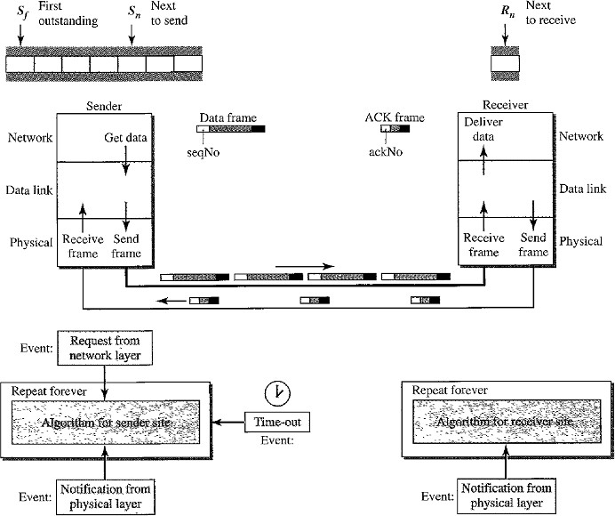

This protocol uses the following concepts:
- Sequence Numbers
- Sliding Window
- Timers
- Acknowledgement
- Retransmission (Resending a Frame)

Sequence Numbers
- It is a number given to each frame included in the header.
- The header of the frame allows m bits for the sequence number, the sequence numbers range from 0 to 2^{m}-1.
- The sequence numbers are repeated after the number 2^{m}-1 (i.e) the sequence numbers are modulo-2^{m}
Example:
If m=4 , the sequence numbers are 0,1,2,3,4,5………14,15,0,1,2,3,4,5,6,…………………..

Sliding Window
Sliding Window is an abstract concept that defines the sender and receiver needs to deal with only part of the possible sequence numbers.
There are 2 types of windows are used:
  - Send Window
  - Receive Window
The range that is the concern of sender is called the send sliding window or Send Window The range that is the concern of receiver is called receive sliding window or receive window.

Send Window
- The send window is an imaginary box covering the sequence numbers of the data frames which can be in transit.
- In each window position, some of these sequence numbers define the frames that have been sent; others define those that can be sent.
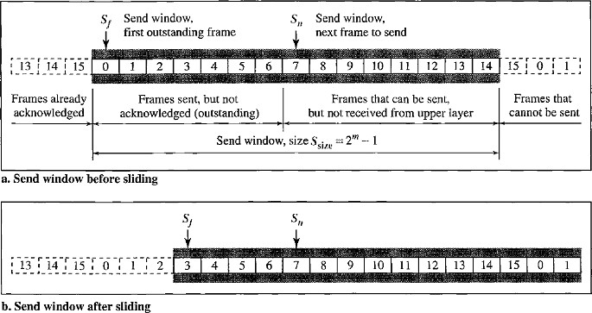
- The maximum size of the send window is 2^{m} – 1. Example: Let us take m=4. Size of window=15. Consider the below figure:
The window at any time divides the possible sequence numbers into four regions.
- The first region (the left side of the window) defines the sequence numbers belonging to frames that are already acknowledged. The sender don‟t need to keep copies of the frames.
- The second region defines the range of sequence numbers belonging to the frames that are sent and have an unknown status. The sender needs to wait to find out if these frames have been received or were lost. These frames are called outstanding frames.
- The third range defines the range of sequence numbers for frames that can be sent. The corresponding data packets have not yet been received from the network layer.
- The fourth region defines sequence numbers that cannot be used until the window slides.
The window uses three variables define its size and location at any time.
  - S_{f} defines the sequence number of the first (oldest) outstanding frame.
  - S_{n} holds the sequence number that will be assigned to the next frame to be sent.
  - S_{size} defines the size of the window, which is fixed in our protocol.
The acknowledgments in this protocol are cumulative, meaning that more than one frame can be acknowledged by an ACK frame.
In the above figure frames 0, 1, and 2 are acknowledged, so the window has slid to the right three slots.

Receive Window
- The receive window makes sure that the correct data frames are received and that the correct acknowledgments are sent.
- The size of the receive window is always 1.
- The receiver is always looking for the arrival of a specific frame.
- Any frame arriving out of order is discarded and needs to be resent.
There is only one variable required, that is R_{n}
R_{n}: defines next frame expected, belongs to Receive Window.
- The sequence numbers to the left of the window belong to the frames already received and acknowledged.
- The sequence numbers to the right of this window define the frames that cannot be received.
- Any received frame with a sequence number in these two regions is discarded.
- Only a frame with a sequence number matching the value of R_{n} is accepted and acknowledged. (i.e. S_{n}=R_{n})
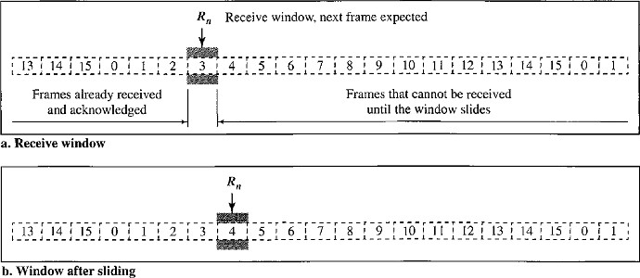
- The receive window slides only one slot at a time, when the correct frame is received the window slides.

Timers
The timer for the first outstanding frame always expires first.We send all outstanding frames when this timer expires.

Acknowledgment
- The receiver sends a positive acknowledgment if a frame has arrived safe and sound and in order.
- If a frame is damaged or frame is received out of order, the receiver is silent and will discard all subsequent frames until it receives the one it is expecting.
- The silence of the receiver causes the timer of the unacknowledged frame at the sender site to expire. This causes the sender to go back and resend all frames, beginning with the one with the expired timer.
- The receiver does not have to acknowledge each frame received. It can send one cumulative acknowledgment for several frames.

Retransmission (Resending a Frame)
When the timer expires, the sender resends all outstanding frames. Example:
- Suppose the sender has already sent frame 6, but the timer for frame 3 expires.
- This means that frame 3 has not been acknowledged.
- The sender goes back and sends frames 3, 4,5, and 6 again.
- That is why the protocol is called Go-Back-N ARQ.

Flow Diagram
The below shows what happens when a frame is lost.
- Frames 0, 1, 2, and 3 are sent.
- Frame 0 is acknowledged but Frame 1 is lost.
- The receiver receives frames 2 and 3, but they are discarded because they are received out of order (frame 1 is expected).
- The sender receives no acknowledgment about frames 1, 2, or 3.
- Its timer finally expires. The sender sends all outstanding frames (1, 2, and 3) because it does not know whether the frame is lost or corrupted.
- Note that the resending of frames l, 2, and 3 is the response to one single event.
- When the sender is responding to this event, it cannot accept the triggering of other events.
- This means that when ACK 2 arrives, the sender is still busy with sending frame 3.
- The physical layer must wait until this event is completed and the data link layer goes back to its sleeping state.
- Vertical line in the figure is to indicate the delay.
Note that before the second timer expires, all outstanding frames have been sent and the timer is stopped.

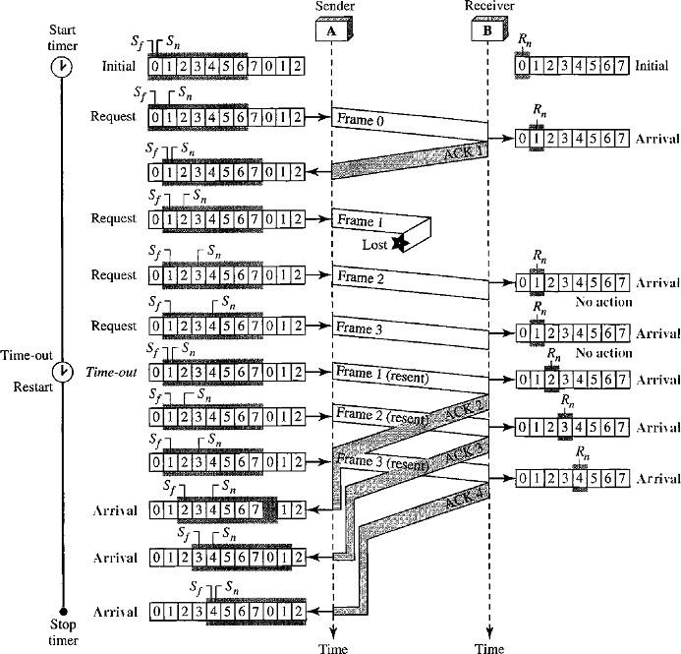

Disadvantage with Go-Back-N ARQ
Go-Back-N ARQ protocol is very inefficient for a noisy link.
- Go-Back-N ARQ simplifies the process at the receiver site.
- The receiver keeps track of only one variable, and there is no need to buffer out-of-order frames and they are simply discarded.
- In a noisy link a frame has a higher probability of damage; so it leads to the resending of multiple frames.
- This resending uses more bandwidth and slows down the transmission. This is a major disadvantage.
Solution: When there is just one frame is damaged, then only the damaged frame is resent, instead of resending from N^{th} frame. This will be achieved by using Selective Repeat ARQ Protocol.

SELECTIVE REPEAT Automatic Repeat Request
It is more efficient for Noisy links but processing at the receiver is more complex.

Design Window Sizes
Window size 2^{m-1} means the size of the sender and receiver window is at most one half of 2^{m} (i.e 2^{m}/2).

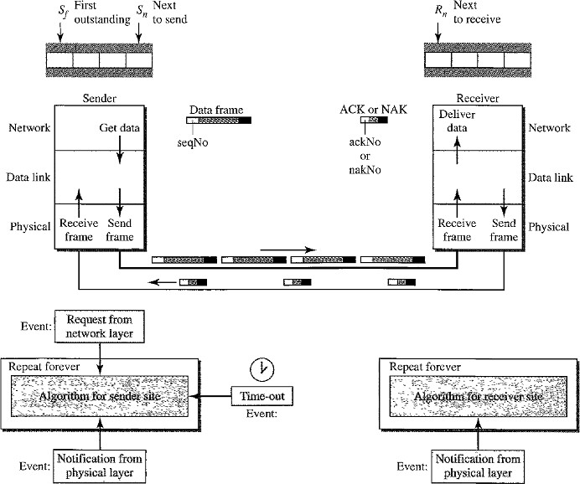

Windows
It uses two windows:
- Send Window
- Receive Window
The size of the send window and receive window is same as 2^{m-1.}
Example: If m = 4, the sequence numbers ranges from 0 to 15, but the size of the window is just 8.
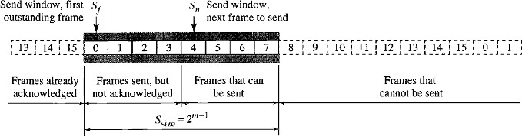
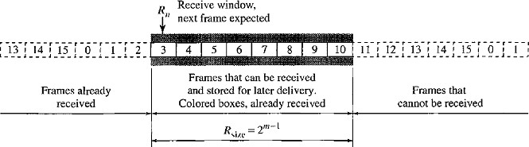

- The Selective Repeat Protocol allows as many frames as the size of the receive window to arrive out of order and be kept until there is a set of in-order frames to be delivered to the network layer.
- Because the sizes of the send window and receive window are the same, all the frames in the send frame can arrive out of order and be stored until they can be delivered.
- We need to mention that the receiver never delivers packets out of order to the network layer.
- Those slots inside the receive window that are colored define frames that have arrived out of order and are waiting for their neighbors to arrive before delivery to the network layer.

Sender site:
- For every request event a timer is started before sending any frame. The arrival event is more complicated. An ACK or a NAK frame may arrive at the sender site.
- If a valid NAK frame arrives, we just resend the corresponding frame.
- If a valid ACK arrives 3 actions will be done:
- Purge the buffers
- Stop the corresponding timer
- Move the left wall of the window.
- The time-out event is simpler, only the frame which times out is resent.

Receiver site:
- Receiver sends ACK and NAK frames to sender.
- If the Receiver receives a corrupted frame and a NAK has not yet been sent, Receiver sends a NAK to tell the sender that we have not received the frame we expected.
- If the frame is not corrupted and the sequence number is in the window, Receiver stores the frame and marks the slot.
- If contiguous frames, starting from R_{n} have been marked, Data link layer delivers their data to the network layer and slide the window.

Flow Diagram
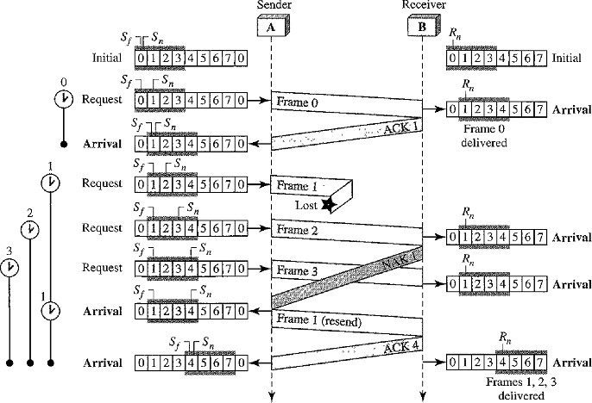
By looking at the below flow diagram, we can observe below points:

Timers
- Each frame sent or resent needs a timer and the timers needs to be numbered such as 0,1,2,3..etc.
- The timer for frame 0 starts at the first request, but stops when the ACK for this frame arrives.
- The timer for frame 1 starts at the second request and restarts when a NAK arrives, and finally stops when the last ACK arrives.
- The other two timers start when the corresponding frames are sent and stop at the last arrival event.

Receiver Site
- At the receiver site we need to distinguish between the acceptance of a frame and its delivery to the network layer.
- At the second arrival, frame 2 arrives and is stored and marked (colored slot), but it cannot be delivered because frame 1 is missing.
- At the next arrival, frame 3 arrives and is marked and stored, but still none of the frames can be delivered.
- Only at the last arrival, when finally a copy of frame 1 arrives and frames 1, 2, and 3 be delivered to the network layer.
- There are two conditions for the delivery of frames to the network layer:
- a set of consecutive frames must have arrived.
- the set starts from the beginning of the window.
- After the first arrival, there was only one frame and it started from the beginning of the window.
- After the last arrival, there are three frames and the first one starts from the beginning of the window.

Importance of NAK’s
- Here a NAK is sent after the second arrival, but not after the third.
- The reason is that the protocol does not want to crowd the network with unnecessary NAKs and unnecessary resent frames.
- The second NAK would still be NAK1 to inform the sender to resend frame 1 again; this has already been done.
- The first NAK sent is remembered and is not sent again until the frame slides.
- A NAK is sent once for each window position and defines the first slot in the window.

Importance of ACK’s
- There are only two ACKs are sent here. The first one acknowledges only the first frame The second one acknowledges three frames.
- In Selective Repeat, ACKs are sent when data are delivered to the network layer.
- If the data belonging to n frames are delivered in one shot, only one ACK is sent for all of them.
- In the above figure frame 1,2,3, are sent to Network layer and then ACK4 is sent, to represent that Frame1, Frame2, Frame3 are delivered.
There is a question arises that :

Why the size of the sender and receiver windows is 2^{m-1}?
Sol: For an example, take m = 2, which means the size of the window is 2^{m}/2, or 2. Now we compare window size=2 and window size =3.

Window size=2
- If the size of the window is 2 and all acknowledgments are lost, the timer for frame 0 expires and frame 0 is resent.
- The window of the receiver is now expecting frame 2, not frame 0, so this duplicate frame is correctly discarded.
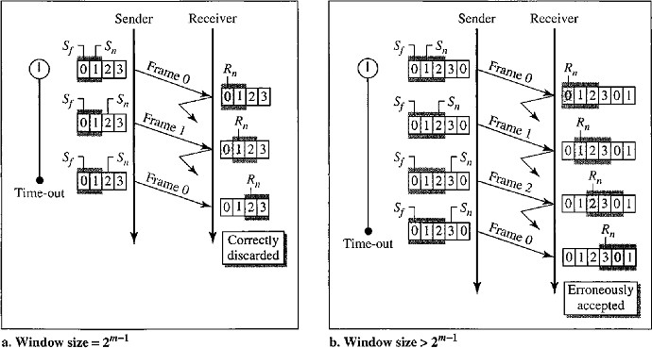

Window Size=3
- When the size of the window is 3 and all acknowledgments are lost, the sender sends a duplicate of frame 0.
- However, this time, the window of the receiver expects to receive frame 0 (0 is part of the window), so it accepts frame 0, not as a duplicate, but as the first frame in the next cycle.
- This is clearly an error.

PIGGYBACKING
- The protocols Stop-and-wait ARQ, Go-Back-N ARQ, Selective Repeat ARQ are all unidirectional. That means data frames flow in only one direction although control information such as ACK and NAK frames can travel in the other direction.
- In real life, data frames are normally flowing in both directions: from node A to node B and from node B to node A. This means that the control information also needs to flow in both directions. This technique called piggybacking.
- Piggybacking is used to improve the efficiency of the bidirectional protocols. When a frame is carrying data from A to B, it can also carry control information from B to A. Similarly when a frame is carrying data from B to A, it can also carry control information frames from A to B.

HIGH-LEVEL DATA LINK CONTROL (HDLC)
HDLC is a bit-oriented protocol for communication over point-to-point and multipoint links.
It implements the ARQ mechanisms.
HDLC provides two common transfer modes that can be used in different configurations:
- Normal Response Mode (NRM)
- Asynchronous Balanced Mode (ABM)
Normal Response Mode (NRM) | Asynchronous Balanced Mode
- In normal response mode (NRM), the station configuration is unbalanced.  - We have one primary station and multiple secondary stations.  - A primary station can send commands; a secondary station can only respond.  - The NRM is used for both point-to-point and multiple-point links. | - In asynchronous balanced mode (ABM), the configuration is balanced.  - Each station can function as a primary and a secondary station.  - Both Primary and Secondary stations can send Commands and Responces.  - The link is point-to-point.

Frames
HDLC defines three types of frames, each type of frame serves as an envelope for the transmission of a different type of message.

Information frames (I-frames)
I-frames are used to transport user data and control information relating to user data. Only I-frames uses piggybacking.

Supervisory frames (S-frames)
S-frames are used only to transport control information (i.e. ACK,NAK)

Unnumbered frames (U-frames)
U-frames are reserved for system management. Information carried by U-frames is intended for managing the link itself. U-frames do not have sequence numbers.

Frame Format
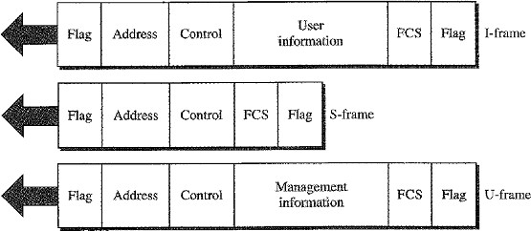
The below figure describes different frames and their fields where as a beginning flag field, an address field, a control field and an ending flag field is common in all frames.

Flag field
- The flag field of an HDLC frame is an 8-bit sequence with the bit pattern 01111110 that identifies both the beginning and the end of a frame and serves as a synchronization pattern for the receiver.

Address field
- The second field of an HDLC frame contains the address of the secondary station.
- If a primary station created the frame, it contains a “to address”.
- If a secondary creates the frame, it contains a “from address”.
- An address field can be 1 byte or several bytes long, depending on the needs of the network. One byte (8-bits) can identify up to 128 stations (2⁷=2⁸⁻¹).
- Larger networks require multiple-byte address fields.
- If the address field is only 1 byte, the last bit is always a “1”.
- If the address is more than 1 byte, all bytes but the last one will end with 0; only the last will end with 1.
- Ending each intermediate byte with 0 indicates to the receiver that there are more address bytes to come.

Control field
- The control field is a 1-byte or 2-byte segment of the frame used for flow and error control.

Information field
- The information field contains the user's data from the network layer or management information. Its length can vary from one network to another.

FCS field
- Frame Check Sequence (FCS) is the HDLC error detection field.
- FCS contains either a 2-byte or 4-byte ITU-T CRC (i.e CRC-16 or CRC-32).

Control Field
The control field determines the type of frame and defines its functionality. If the first 2 bits of control field determines the type:
- If first bit is 0, then it is I-Frame.
- If first 2 bits are 10, then it is S-Frame.
- If first 2 bits are 11, then it is U-Frame.

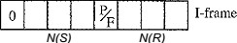
Control Field for I-Frames
- The first bit is 0, that defines it is I-Frame.
- I-frames are designed to carry user data from the network layer.
- I-Frames can include flow and error control information (piggybacking). The subfields in the control field are used to define these functions.
- N(S) is a 3 bit sequence number of a frame occupies 2nd, 3rd, 4th bits. The range of sequence numbers are 0-7.
- N(R) is 3 bit acknowledgement number occupies last 3 bits (i.e. 6th, 7th, 8th bits) used for Piggybacking.
- P/F (Poll/Final) bit is the 5th bit, it is a single bit with dual purpose, and it has to set to value„1‟.
- poll means when the frame is sent by a primary station to a secondary, (i.e.) when the address field contains the address of the receiver.
- final means when the frame is sent by a secondary to a primary, (i.e.)when the address field contains the address of the sender.

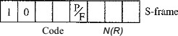
Control Field for S-Frames
- If the first 2 bits of the control field is 10, this means the frame is an S-frame.
- Supervisory frames are used for flow and error control whenever piggybacking is either impossible or inappropriate.
- S-frames do not have information fields.
- The last 3 bits, called N(R), corresponds to the acknowledgment number (ACK) or negative acknowledgment number (NAK) depending on the type of S-frame.
The 2 bits called code is used to define the type of S-frame,

Receive Ready (RR) S-frame (00)
- RR S-frame acknowledges the receipt of a safe and sound frame or group of frames.
- The value N(R) field defines the Acknowledgment Number (ACK).

Receive Not Ready (RNR) S-Frame (10)
- It acknowledges the receipt of a frame or group of frames, and it announces that the receiver is busy and cannot receive more frames.
- It acts as a kind of congestion control mechanism by asking the sender to slow down.
- The value of N(R) is the Acknowledgment Number (ACK).

Reject (REJ) S-Frame (01)
- It is a NAK frame that can be used in Go-Back-N ARQ to improve the efficiency of the process by informing the sender, before the sender time expires, that the last frame is lost or damaged.
- The value of N(R) is the Negative Acknowledgment Number (NAK).

Selective Reject (SREJ) S-Frame (11)
- This is a NAK frame used in Selective Repeat ARQ.
- The value of N(R) is the Negative Acknowledgment Number (NAK).

S-Frame Type | Code | N(R) | Usage
RR | 00 | ACK | Acknowledge the receipt of safe & sound frame.
RNR | 10 | ACK | Informs sender that Receiver is busy.
REJ | 01 | NAK | Used in Go-Back-N ARQ.
SREJ | 11 | NAK | Used in Selective Repeat ARQ.

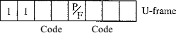
Control Field for U-Frames
- Unnumbered frames are used to exchange session management and control information between connected devices.
- U-frames contains Information field, but one used for system management information, not user data.
- U-frame codes are divided into two sections: (2+3=5 bits)
  - A 2-bit prefix before the P/F bit
  - 3-bit suffix after the P/F bit
- Together, these two segments (5 bits) can be used to create up to 32 different types of U- frames.
Code | Command | Response | Meaning
00 001 | SNRM |  | Set normal response mode
11 011 | SNRME |  | Set normal response mode, extended
11 100 | SAMB | DM | Set asynchronous balanced mode or disconnect mode
11 110 | SABME |  | Set asynchronous balanced mode, extended
00 000 | UI | UI | Unnumbered information
00 110 |  | UA | Unnumbered Acknowledgement
00 010 | DISC | RD | Disconnect or request disconnect
10 000 | SIM | RIM | Set initialization mode or request information mode
00 100 | UP |  | Unnumbered poll
11 001 | RSET |  | Reset
11 101 | XID | XID | Exchange ID
10 001 | FRMR | FRMR | Frame reject

POINT-TO-POINT PROTOCOL (PPP)
Point-to-Point Protocol one of the most common protocols for point-to-point access.
Millions of Internet users who need to connect their home computers to the server of an Internet service provider use PPP.
The majority of these users have a traditional modem; they are connected to the Internet through a telephone line, which provides the services of the physical layer. But to control and manage the transfer of data, there is a need for a point-to-point protocol at the data link layer.

PPP-Services
- PPP defines the format of the frame to be exchanged between devices.
- PPP defines how two devices can negotiate the establishment of the link and the exchange of data.
- PPP defines how network layer data are encapsulated in the data link frame.
- PPP defines how two devices can authenticate each other.
- PPP provides multiple network layer services supporting a variety of network layer protocols.
- PPP provides connections over multiple links.
- PPP provides network address configuration. This is particularly useful when a home user needs a temporary network address to connect to the Internet.

Limitations of PPP
- No Flow control
PPP does not provide flow control. A sender can send several frames one after another with no concern about overwhelming the receiver.

Lack of error control
PPP has a very simple mechanism for error control. A CRC field is used to detect errors. If the frame is corrupted, it is silently discarded; the upper-layer protocol needs to take
care of the problem. Lack of error control and sequence numbering may cause a packet to be received out of order.

No Effective Addressing
PPP does not provide a sophisticated addressing mechanism to handle frames in a multipoint configuration.

Framing
PPP is a byte-oriented protocol. Frame Format consisting of: Flag, Address, Control, Protocol, Payload, FCS.
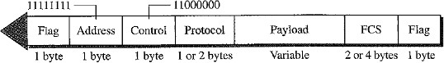

Flag
- A PPP frame starts and ends with a 1-byte flag with the bit pattern 01111110.
- PPP is a byte-oriented protocol. The flag is treated as a byte.

Address
- The address field in this protocol is a constant value and set to broadcast address (11111111).
- During negotiation the two parties (sender and receiver) may agree to omit this byte.

Control
- This field is set to the constant value 11000000.
- PPP does not provide any flow control.
- Error control is also limited to error detection.
- This field byte is omitted after negotiation of two parties.

Protocol
- The protocol field defines what is being carried in the data field: either user data or other information such as ACK,NAK etc.
- The length of the field is either 1 or 2-bytes.

Payload field
- This field carries either the user data or other information.
- The data field is a sequence of bytes with the default of a maximum of 1500 bytes;
- The data field is byte stuffed if the flag byte pattern appears in this field. Because there is no field defining the size of the data field, padding is needed if the size is less than the maximum default value or the maximum negotiated value.

FCS
- The frame check sequence (FCS) is simply a 2-byte or 4-byte standard CRC.
Byte Stuffing
- PPP is a byte-oriented protocol whereas HDLC is a bit oriented protocol.
- The flag in the PPP is a byte; it needs to be escaped whenever it appears in the data section of the frame.
- Every time the flag like pattern appears in the data, the Escape Byte (ESC) is 01111101, stuffed to tell the receiver that the next byte is not a flag.

Transition Phases
A PPP connection goes through 6 transition phases:
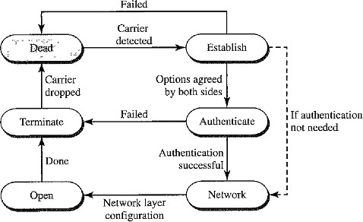

Dead
- In the dead phase the link is not being used.
- There is no active carrier at the physical layer and the line is quiet.

Establish
- When one of the nodes starts the communication, the connection goes into this phase.
- In this phase, options are negotiated between the two parties (sender and receiver).
- If the negotiation is successful, the system goes to the authentication phase or directly to the networking phase.

Authenticate
- The authentication phase is optional.
- In the authentication phase the two nodes send several authentication packets.
- If the result is successful then the connection goes to the Networking phase;
- If result is not successful then the connection goes to the Termination phase.

Network
- In the network phase, negotiation for the network layer protocols takes place.
- PPP specifies that two nodes establish a network layer agreement before data at the network layer can be exchanged.
- The reason is that PPP supports multiple protocols at the network layer.
- If a node is running multiple protocols simultaneously at the network layer, the receiving node needs to know which protocol will receive the data.

Open
- In the open phase, data transfer takes place.
- When a connection reaches this phase, the exchange of data packets can be started.
- The connection remains in this phase until one of the endpoints wants to terminate the connection.

Terminate
- In the termination phase the connection is terminated.
- Several packets are exchanged between the two ends for closing the link.

MULTIPLE ACCESS RESOLUTION PROTOCOLS
The Data Link Layer can be divided into 2 sublayers:
- Data Link Control
- Multiple Access Resolution
- The Multiple access resolution layers is responsible for resolving access to the shared media.
- Multiple Access Resolution layer is needed only when the channel is not dedicated. If the channel is dedicated then there is no need for multiple access sublayer.
- When nodes or stations are connected and use a common link, called a Multipoint link or
Broadcast link, we need a multiple-access protocol to coordinate access to the link.
- The protocols have been devised to handle access to a shared link are called Multiple Access Resolution Protocols.
These protocols are categorized as below:
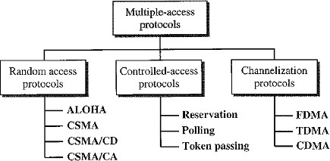

Random Access Protocols
Random Access method is also called Contention method.
- There is no scheduled time for a station to transmit. Transmission is random among the stations. That is why these methods are called Random Access methods.
- There are no rules to specify which station should send next. Stations compete with one another to access the medium. That is why these methods are also called Contention Methods.
At each instance, a station that has data to send, uses a procedure defined by the protocol to make a decision on whether to send the data or not to send the data. This decision depends on the state of the medium (idle or busy).
In this method:
- No station is superior to another station.
- No station is assigned the control over another station.
- No station permits or does not permit another station to send.
In this method, each station has the right to the medium without being controlled by any other station. If more than one station tries to send, there is an Access Conflict-Collision and the frames will be either destroyed or modified during the collision.
In order to avoid these collisions 4 protocols are implemented, they are:
- ALOHA
- CSMA
- CSMA/CD
- CSMA/CA

ALOHA
ALOHA was developed at the University of Hawaii in early 1970. It was designed for a Wireless radio LAN, but it can be used on any shared medium. Due to shared medium there are potential collisions in this arrangement.
There are two types of methods in ALOHA
- Pure ALOHA
- Slotted ALOHA

Pure ALOHA
The original ALOHA or Pure ALOHA is a simple protocol.
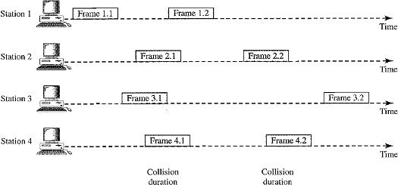
The idea is that each station sends a frame whenever it has a frame to send, there is only one channel to share, and there is the possibility of collision between frames from different stations.
- In the above figure, there are four stations each sending two frames and shares the same channel. Some of these frames collide because multiple frames are in contention for the shared channel.
- By observing the above figure only 2 frames frame 1.1 and frame 3.2 can be delivered at receiver, and the remaining frames collide with each other and they are lost or discarded at the receiver side.
- The pure ALOHA protocol relies on Acknowledgments (ACK) from the receiver. When a station sends a frame, it expects the receiver to send an acknowledgment.
- If the acknowledgment does not arrive after a time-out period, the station assumes that the frame (or the acknowledgment) has been destroyed and resends the frame.
- A collision involves two or more stations. If all these stations try to resend their frames after the time-out, the frames will collide again.
- Pure ALOHA dictates that when the time-out period passes, each station waits a random amount of time before resending its frame. The randomness will help avoid more collisions; this time is called the Back-Off Time T_{B}.
- Pure ALOHA has a second method to prevent congesting the channel with retransmitted frames. After a maximum number of retransmission attempts K_{max} a station must give up and try later.
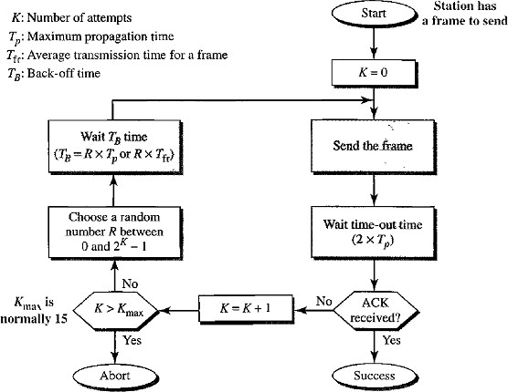
The procedure for pure ALOHA is given in the figure:
- The time-out period is equal to the maximum possible round-trip propagation delay, which is twice the amount of time required to send a frame between the two most widely separated stations (2 x Tp).
- The back-off time TB is a random value that normally depends on K (the number of attempted unsuccessful transmissions).
- For each retransmission, a multiplier in the range 0 to 2^{K} - 1 is randomly chosen and multiplied by Tp (maximum propagation time) or T_{fr} (Frame transmission time or the average time required to send out a frame) to find T_{B}.
- Note that in this procedure, the range of the random numbers increases after each collision. The value of Kmax is usually chosen as 15.

Vulnerable time
Vulnerable time is the length of time, in which there is a possibility of collision.
Let us assume that the stations send fixed-length frames with each frame taking T_{fr}’s to send. Station A sends a frame at time t.
Now station B has already sent a frame between t - T_{fr} and t.
This leads to a collision between the frames from station A and station B. The end of B's frame collides with the beginning of A's frame.

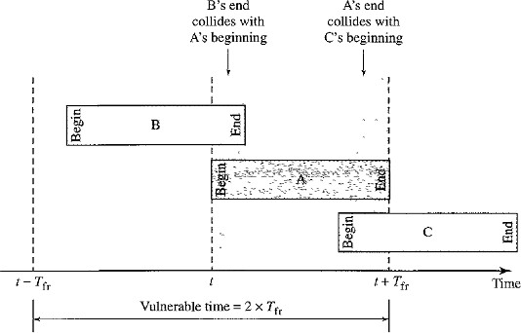
Suppose that station C sends a frame between t and t + T_{fr} .
Here, there is a collision between frames from station A and station C. The beginning of C's frame collides with the end of A's frame.
The vulnerable time, during which a collision may occur in pure ALOHA, is 2 times the frame transmission time.
Pure ALOHA vulnerable time = 2 x T_{fr}

Throughput
- The throughput for pure ALOHA is S = G x e^{-2G}
.
- The maximum throughput S_{max} = 0.184 when G = (½).
- (i.e.) one frame is generated during two frame transmission times, then 18.4 percent of these frames reach their destination successfully.

Slotted ALOHA
Pure ALOHA has a vulnerable time of 2 x T_{fr} . This is so because there is no rule that defines when the station can send.
- A station may send soon after another station has started or soon before another station has finished.
- Slotted ALOHA was invented to improve the efficiency of pure ALOHA.
- In slotted ALOHA we divide the time into slots of T_{fr}‟s and force the station to send only at the beginning of the time slot.
- A station is allowed to send only at the beginning of the synchronized time slot, if a station misses this moment, it must wait until the beginning of the next time slot.
- This means that the station which started at the beginning of this slot has already finished sending its frame.
- There is still the possibility of collision if two stations try to send at the beginning of the same time slot.
i.e. the vulnerable time for slotted ALOHA is one-half that of pure ALOHA.
Slotted ALOHA vulnerable time = T_{fr}.
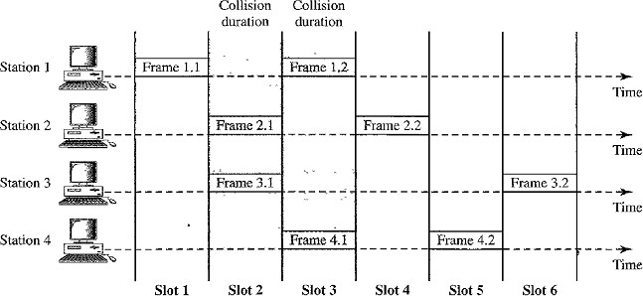
Below figure shows an example of frame collisions in slotted ALOHA.

Throughput
- The throughput for slotted ALOHA is S =: G x e^{-G}.
- The maximum throughput S_{max} == 0.368 when G =1.
- If a frame is generated during one frame transmission time, then 36.8 percent of these frames reach their destination successfully.

Carrier Sense Multiple Access (CSMA)
CSMA was developed to minimize the chance of collision and improve the performance, but it cannot eliminate the collision.
- CSMA is based on the principle of “sense before transmit” or “listen before talk”.
- That means, CSMA requires that each station first listen to the medium or check the state of the medium before sending. Stations are connected to a shared channel.
- Collision occurs due to propagation delay. (i.e.) when a station sends a frame, it still takes time for the first bit to reach every station and for every station to sense it.
- At time t1, station B senses the medium and finds it idle, so it sends a frame.
- At time t2 (t2> t1) station C senses the medium and finds it idle because at this time, the first bits from station B have not reached station C.
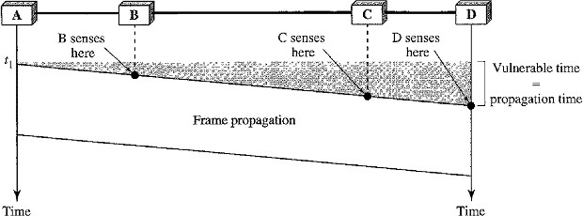
- Station C also sends a frame. The two signals collide and both frames are destroyed.

Vulnerable Time of CSMA
Vulnerable Time= Propagation Time
- It is the time needed for a signal to propagate from one end of the medium to the other.
- The leftmost station A sends a frame at time t1 which reaches the rightmost station D at time t₁ + T_{p} .

Persistence Methods
Persistence methods define what action will be taken by a station if the channel is busy or idle. There are 3 methods in persistence method:

1-persistent method
- 1-persistent method is simple and straightforward.
- In this method, after the station finds the line idle, it sends its frame immediately (with probability 1).
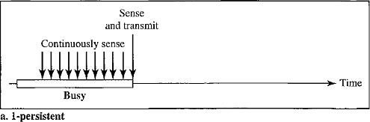
- This method has the highest chance of collision because two or more stations may find the line idle and send their frames immediately.

Non-persistent Method
- In the non-persistent method, a station that has a frame to send senses the line. If the line is idle, it sends immediately.
- If the line is not idle, it waits a random amount of time and then senses the line again.
- The non-persistent approach reduces the chance of collision because it is unlikely that two or more stations will wait the same amount of time and retry to send simultaneously.
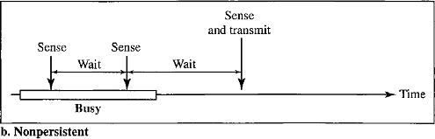
- However, this method reduces the efficiency of the network because the medium remains idle when there may be stations with frames to send.

p-Persistent Method
- The p-persistent method is used if the channel has time slots with a slot duration equal to or greater than the maximum propagation time.
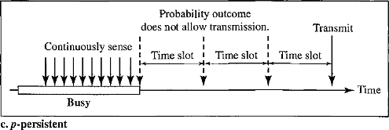
- It reduces the chance of collision and improves efficiency.
In this method, after the station finds the line idle it follows these steps:
- With probability p, the station sends its frame.
- With probability q = 1 - p, the station waits for the beginning of the next time slot and checks the line again.
- If the line is idle, it goes to step 1.
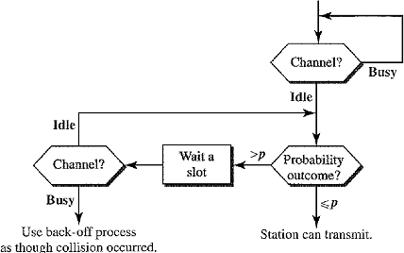
- If the line is busy, it acts as though a collision has occurred and uses the backoff procedure.

Carrier Sense Multiple Access with Collision Detection (CSMA/CD)
CSMA method does not specify the procedure following a collision but CSMA/CD augments the algorithm to handle the collision.
In this method, a station monitors the medium after it sends a frame to see if the transmission was successful.
- If it is successful the station is finished.
- If it not successful and there is a collision, the frame is sent again.
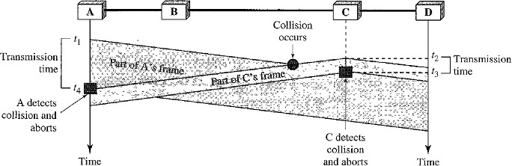
- At time t 1, station A has executed its persistence procedure and starts sending the bits of its frame.
- At time t2, station C has not yet sensed the first bit sent by A.
- Station C executes its persistence procedure and starts sending the bits in its frame, which propagate both to the left and to the right.
- The collision occurs sometime after time t2 Station C detects a collision at time t3 when it receives the first bit of A's frame. Station C immediately aborts transmission.
- Station A detects collision at time t4 when it receives the first bit of C's frame; it also immediately aborts transmission.
- A transmits for the duration t4 – t1; C transmits for the duration t3 - t2
- At time t4, the transmission of A‟s frame is aborted; at time t3, the transmission of C's frame is aborted. Both are incomplete.
- This is so because the station, once the entire frame is sent, does not keep a copy of the frame and does not monitor the line for collision detection.
Minimum Frame Size (2Tp)
If the two stations involved in a collision are the maximum distance apart, the signal from the first station takes Tp time to reach the second station and the effect of the collision takes another Tp time to reach the first station.
Therefore, the frame transmission time T_{fr} must be at least two times the maximum propagation time Tp. So the first station must still be transmitting after 2Tp .

Procedure
- We need to sense the channel before we start sending the frame by using one of the persistence processes.
- In ALOHA, we first transmit the entire frame and then wait for an acknowledgment. In
CSMA/CD, transmission and collision detection is a continuous process.
- We do not send the entire frame and then look for a collision. The station transmits and receives continuously and simultaneously using two different ports.
- We use a loop to show that transmission is a continuous process.
- We constantly monitor in order to detect one of two conditions:
either transmission is finished or a collision is detected. Either event stops transmission.
- When we come out of the loop, if a collision has not been detected, it means that transmission is complete; the entire frame is transmitted. Otherwise, a collision has occurred.
- Here we send a short jamming signal that enforces the collision in case other stations have not yet sensed the collision.
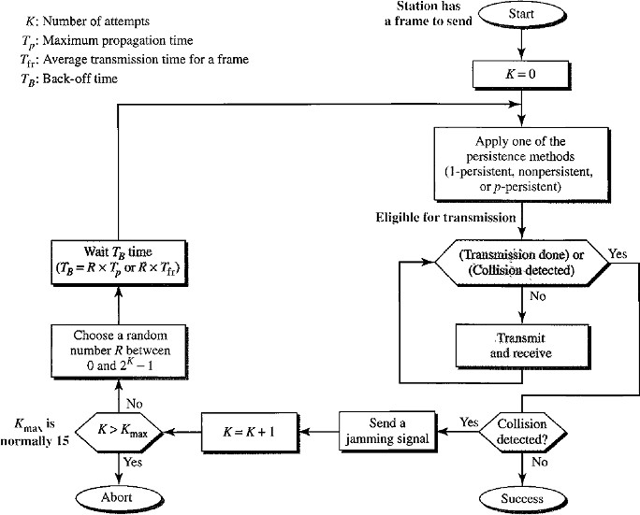

Carrier Sense Multiple Access with Collision Avoidance (CSMA/CA)
Wireless networks cannot detect collisions, hence we need to avoid collision.

Need for CSMA/CA
- In a wired network, the received signal has almost the same energy as the sent signal because either the length of the cable is short or there are repeaters that amplify the energy between the sender and the receiver. The detected energy almost doubles when there is a collision.
- In a wireless network much of the Sent Energy is lost in transmission. The received signal has very little energy. Therefore a collision may add only 5 to 10 percent additional energy. This is not useful for effective collision detection.
- Hence in a wireless networks we need to avoid collisions instead of detecting collisions. In order to avoid collisions CSMA/CA was introduced for wireless networks.
CSMA/CA uses three strategies to avoid collisons:
- InterFrame Space
- Contention Window
- Acknowledgements
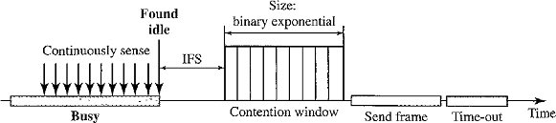
The below figure shows the timing in CSMA/CA:

Interframe Space (IFS)
- Collisions are avoided by deferring transmission even if the channel is found idle. When an idle channel is found, the station does not send immediately. It waits for a period of time called the interframe space or IFS.
- Even though the channel may appear idle when it is sensed, a distant station may have already started transmitting.
- The distant station's signal has not yet reached this station. The IFS time allows the front of the transmitted signal by the distant station to reach this station.
- If after the IFS time the channel is still idle, the station can send, but it still needs to wait a time equal to the contention time.
- The IFS variable can also be used to prioritize stations or frame types. For example, a station that is assigned a shorter IFS has a higher priority.

Contention Window
- The contention window is an amount of time divided into slots.
- A station that is ready to send chooses a random number of slots as its wait time.
- The number of slots in the window changes according to the binary exponential back-off strategy. This means that it is set to one slot the first time and then doubles each time the station cannot detect an idle channel after the IFS time.
- A random outcome defines the number of slots taken by the waiting station.
- In contention window, the station needs to sense the channel after each time slot.
- In CSMAlCA, if the station finds the channel busy, it does not restart the timer of the contention window instead it stops the timer and restarts it when the channel becomes idle. This gives priority to the station with the longest waiting time.

Acknowledgment
- The positive acknowledgment and the time-out timer can help guarantee that the receiver has received the frame.
- Acknowledgement is needed even though we take all the precautions, there still may be a collision resulting in destroyed data and the data may be corrupted during the transmission.

Procedure
- The channel needs to be sensed before and after the IFS.
- The channel also needs to be sensed during the contention time.
- For each time slot of the contention window, the channel is sensed.
- If it is found idle, the timer continues.
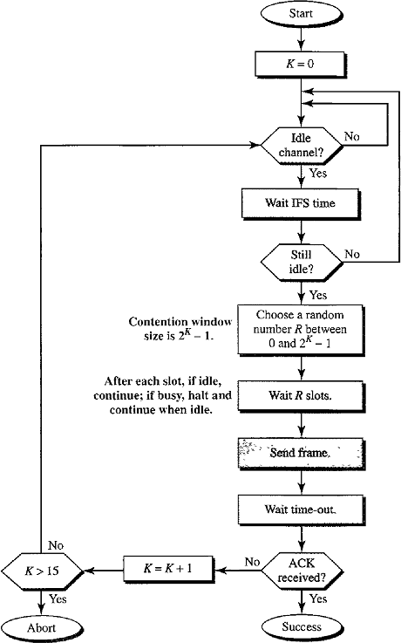
- If the channel is found busy, the timer is stopped and continues after the timer becomes idle a-again.

Token Passing
In this method the stations in a network are organized in a logical ring. That means:
- For each station, there is a predecessor and a successor.
- The predecessor is the station which is logically before the station in the ring.
- The successor is the station which is after the station in the ring.
- The current station is the one that is accessing the channel now.
- The right to this access has been passed from the predecessor to the current station.
- The right will be passed to the successor when the current station has no more data to send.

Steps to get the right to access the channel passed from one station to another station
- A special packet called a token circulates through the ring.
- Possession of the token gives the station the right to access the channel and send its data.
- When a station has some data to send, it waits until it receives the token from its predecessor. It then holds the token and sends its data.
- When the station has no more data to send, it releases the token, passing it to the next logical station in the ring.
- The station cannot send data until it receives the token again in the next round.
- In this process, when a station receives the token and has no data to send, it just passes the data to the next station.

Token Management
- Stations must be limited in the time they can have possession of the token.
- The token must be monitored to ensure it has not been lost or destroyed.
- If a station that is holding the token fails, the token will disappear from the network.
- Another function of token management is to assign priorities to the stations and to the types of data being transmitted.
- Token management is needed to make low-priority stations release the token to high- priority stations.

Logical Ring

Physical Ring topology
- In the physical ring topology, when a station sends the token to its successor, the token cannot be seen by other stations; the successor is the next one in line.
- This means that the token does not have to have the address of the next successor.
- The problem with this topology is that if one of the links between two adjacent stations fails, the whole system fails.

Dual Ring Topology
- The dual ring topology uses a second ring or auxiliary ring which operates in the reverse direction compared with the main ring.
- The second ring is for emergencies only.
- If one of the links in the main ring fails, the system automatically combines the two rings to form a temporary ring.
- After the failed link is restored, the auxiliary ring becomes idle again.
- FDDI and CDDI uses this topology.

Bus Ring Topology or Token Bus
- The stations are connected to a single cable called a bus.
- They make a logical ring, because each station knows the address of its successor and also predecessor.
- When a station has finished sending its data, it releases the token and inserts the address of its successor in the token.
- Only the station with the address matching the destination address of the token gets the token to access the shared media.
- The Token Bus LAN uses this topology.

Star Ring Topology
- The physical topology is a star topology.
- There is a hub that acts as the connector.
- The wiring inside the hub makes the ring and the stations are connected to this ring through the two wire connections.
- This topology makes the network less prone to failure because if a link goes down, it will be bypassed by the hub and the rest of the stations can operate.
- Also adding and removing stations from the ring is easier.
- This topology is still used in the Token Ring LAN designed by IBM.

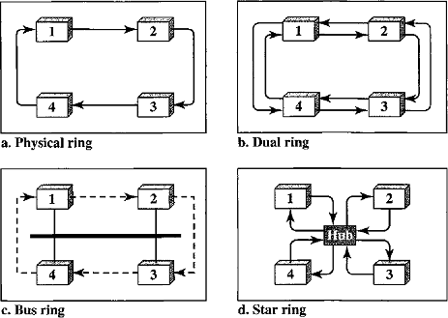

.

Wireless LAN (802.11)
Wireless communication means connecting devices without the use of cables.

Architecture of IEEE 802.11
The standard defines two kinds of services:
- Basic Service Set (BSS)
- Extended Service Set (ESS)

Basic Service Set (BSS)
- IEEE 802.11 defines the basic service set (BSS) as the building block of a wireless LAN.
- BSS is made of stations or Mobile Wireless Stations and the Access Point (AP).
- Access Point is an optional central base station.
- Ad-hoc Architecture: The BSS without an Access Point is a stand-alone network and cannot send data to other BSSs. It is called an Ad-hoc Architecture. In this architecture, stations can form a network without the need of an Access Point; they can locate one another and agree to be part of a BSS.
- A BSS with an AP is sometimes referred to as an Infrastructure Network.
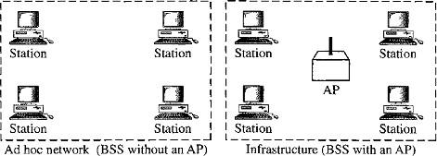

Extended Service Set (ESS)
- ESS is made up of two or more BSSs with Access Points.
- In this case, the BSSs are connected through a distribution system, which is usually a wired LAN. The distribution system connects the Access Points in the BSS‟s.
- The extended service set uses two types of stations: mobile and stationary.
- The mobile stations are normal stations inside a BSS.
- The stationary stations are Access Point stations that are part of a wired LAN.
- When BSSs are connected, the stations within reach of one another can communicate without the use of an AP.
- Communication between two stations in two different BSS usually occurs via two Access Points.
Note: A mobile station can belong to more than one BSS at the same time.
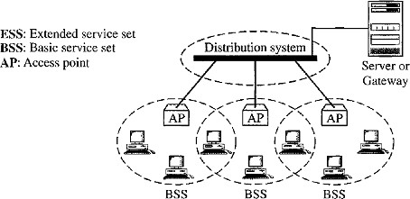

Station Types
IEEE 802.11 defines three types of stations based on their mobility in a wireless LAN:
- No-transition Station A station with no-transition mobility is either stationary (not moving) or moving only inside a BSS.
- BSS-transition Station A station with BSS-transition mobility can move from one BSS to another, but the movement is confined inside one ESS.
- ESS-transition Station A station with ESS-transition mobility can move from one ESS to another.

MAC Sub-layer
IEEE 802.11 defines two MAC sub-layers:
- Distributed Coordination Function (DCF)
- Point Coordination Function (PCF)
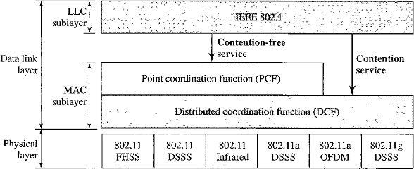
Wireless LANs cannot implement CSMA/CD for three reasons:
- For collision detection a station must be able to send data and receive collision signals at the same time. This approach makes stations costly and increase bandwidth requirements.
- Collision may not be detected because of the hidden station problem.
- The distance between stations can be great. Signal fading could prevent a station at one end from hearing a collision at the other end.

Distributed Coordination Function (DCF)
DCF uses CSMA/CA as the access method. Process Flow Chart of CSMA/CA given below
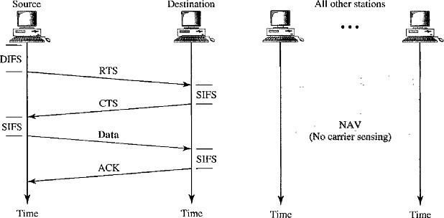
  - Before sending a frame, the source station senses the medium by checking the energy level at the carrier frequency.
    - The channel uses a persistence strategy with back-off until the channel is idle.
    - After the station is found to be idle, the station waits for a period of time called the Distributed Inter-Frame Space (DIFS); then the station sends a control frame called the Request To Send (RTS).
  - After receiving the RTS and waiting a period of time called the Short Inter-Frame Space (SIFS), the destination station sends a control frame called the Clear To Send (CTS) to the source station. This control frame indicates that the destination station is ready to receive data.
  - The source station sends data after waiting an amount of time equal to SIFS.
  - The destination station waits for an amount of time equal to SIFS then sends an acknowledgment to source station to show that the frame has been received.
Note: Acknowledgment is needed in this protocol because the station does not have any mechanism to check for the successful arrival of its data at the destination.

Network Allocation Vector (NAV)
- NAV is a timer used to avoid the collision.
- When a station sends an RTS frame, it includes the duration of time that it needs to occupy the channel.
- The stations that are affected by this transmission create a timer called a Network Allocation Vector (NAV) that shows how much time must pass before these stations are allowed to check the channel for idleness.
- Each time a station accesses the system and sends an RTS frame, other stations start their NAV.
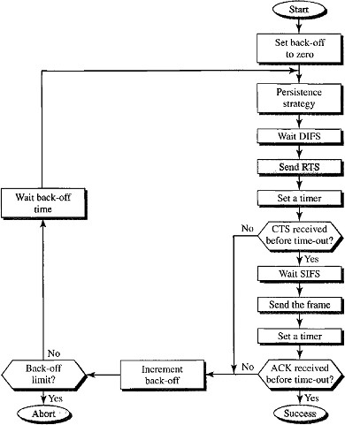

Collision during Handshaking
- Handshaking period is the time taken for the transition of RTS and CTS control frames.
- Two or more stations may try to send RTS frames at the same time. These control frames may collide.
- There is no mechanism for collision detection, the sender assumes there has been a collision if it has not received a CTS frame from the receiver.
- The back-off strategy is employed, and the sender tries again.

Point Coordination Function (PCF)
- The PCF is an optional access method that can be implemented in an infrastructure network (i.e. BSS with Access Point). It is used mostly for time-sensitive transmission.
- PCF has a centralized, contention-free polling access method.
- The Access Point performs polling for stations that are capable of being polled.
- The stations are polled one station after another station if they have any data to send to the Access Point.
- To give priority to PCF over DCF, another set of Inter-Fame spaces has been defined: PIFS (PCF IFS) and SIFS.
- The SIFS is the same as that in DCF, but the PIFS is shorter than the DIFS (i.e.) at the same time, a station wants to use only DCF and an Access Point wants to use PCF then the priority is given to Access Point.
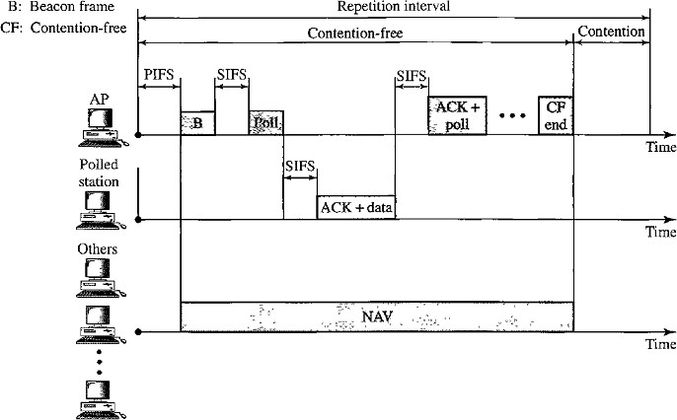

- Due to the priority of PCF over DCF, stations that only use DCF may not gain access to the medium.
- To prevent this, a repetition interval has been designed to cover both contention-free traffic (PCF) and contention-based traffic (DCF).
- The repetition interval, which is repeated continuously, starts with a special control frame, called a Beacon Frame.
- When the stations hear the beacon frame, they start their NAV for the duration of the contention-free period of the repetition interval.
- During the repetition interval, the PC (point controller) can send a poll frame, receive data, send an ACK, receives an ACK etc.

Fragmentation
- The wireless environment is very noisy and a corrupt frame has to be retransmitted. The protocol recommends fragmentation.
- Fragmentation is the division of a large frame into smaller ones. It is more efficient to resend a small frame than a large one.

Frame Format
The MAC layer frame consists of nine fields :
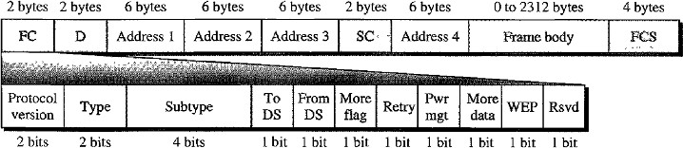

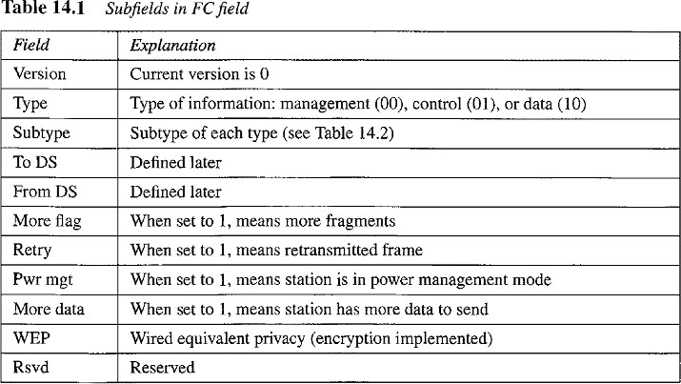
Frame control (FC) The FC field is 2 bytes long and defines the type of frame and some control information.
D: In all frame types except one, this field defines the duration of the transmission that is used to set the value of NAV. In one control frame, this field defines the ID of the frame.

Addresses: There are four address fields, each 6 bytes long. The meaning of each address field depends on the value of the To DS and From DS subfields.
Sequence Control: This field defines the sequence number of the frame to be used in flow control.
Frame Body: This field, which can be between 0 and 2312 bytes, contains information based on the type and the subtype defined in the FC field.
FCS: The FCS field is 4 bytes long and contains a CRC-32 error detection sequence.

Frame Types
A wireless LAN defined by IEEE 802.11 has three categories of frames:

Management Frames (00)
These frames are used for the initial communication between stations and access points.

Control Frames (01)
Control frames are used for accessing the channel and acknowledging frames. The values of the subtype fields for frames:
Subtype | Meaning
1011 | Request To Send (RTS)
1100 | Clear To Send (CTS)
1101 | Acknowledgement (ACK)

Data Frames (10)
Data frames are used for carrying data and control information.

Addressing Mechanism
Flag fields such To DS, From DS can be either 0 or 1, resulting in four different situations. The interpretation of the four addresses (address 1 to address 4) in the MAC frame depends on the value of these flags.
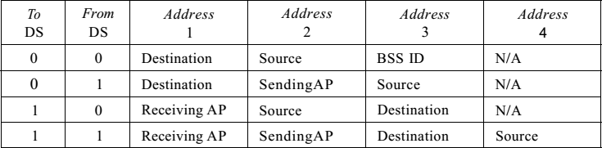
Case 1: 00 (To DS = 0 and From DS = 0)
  - The frame is not going to a distribution system (To DS = 0) and is not coming from a distribution system (From DS =0).
  - The frame is going from one station in a BSS to another without passing through the distribution system.
  - The ACK frame should be sent to the original sender.
Case 2: 01 (To DS = 0 and From DS = 1)
  - The frame is coming from a distribution system (From DS = 1).
  - The frame is coming from an Access Point and going to a station.
  - The ACK should be sent to the Access Point.
Case 3: 10 (To DS = 1 and From DS = 0)
  - The frame is going to a distribution system (To DS = 1).
  - The frame is going from a station to an Access Point.
  - The ACK is sent to the original station.
Case 4:11 (To DS =1 and From DS = 1)
  - This is the case in which the distribution system is also wireless.
  - The frame is going from one AP to another AP in a wireless distribution system.
  - We do not need to define addresses if the distribution system is a wired LAN because the frame in these cases has the format of a wired LAN frame (Ethernet, for example).
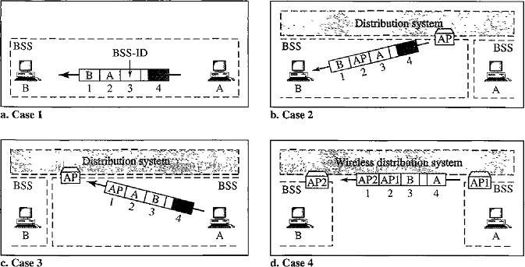
  - Here, we need four addresses to define the original sender, the final destination, and two intermediate APs.

Hidden Station Problems
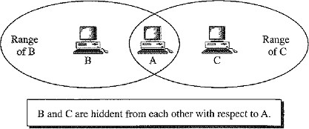
Consider the below figure for Hidden Station problem.
  - Station B has a transmission range shown by the left oval, every station in this range can hear any signal transmitted by station B.
  - Station C has a transmission range shown by the right oval , every station located in this range can hear any signal transmitted by C.
  - Station C is outside the transmission range of B and station B is outside the transmission range of C.
  - Station A is in the area covered by both B and C; Hence A can hear any signal transmitted by B or C.

Problem
  - Station B is sending data to station A. In the middle of this transmission, station C also has data to send to station A.
  - Station C is out of B's range and transmissions from B cannot reach C. Therefore C thinks the medium is free.
  - Station C sends its data to A, which results in a collision at A because this station is receiving data from both B and C.
  - In this case stations B and C are hidden from each other with respect to A.
  - Hidden stations can reduce the capacity of the network because of the possibility of collision.

Solution
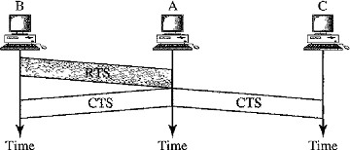
We avoid the above problem by using the Handshake Frames such as RTS & CTS. Consider the below figure:
  - The RTS message from B reaches A, but not C, because both B and C are within the range of A, the CTS message, which contains the duration of data transmission from B to A reaches C.
  - Station C knows that some hidden station is using the channel and refrains from transmitting until that duration is over.

Exposed Station Problem
In this problem a station refrains from using a channel when it is available.
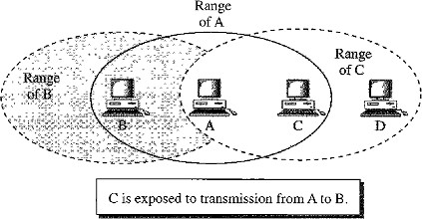
  - Station A is transmitting to station B. Station C has some data to send to station D, which can be sent without interfering with the transmission from A to B.
  - Station C is exposed to transmission from A; it hears what A is sending and thus refrains from sending. That means C is too conservative and wastes the capacity of the channel.

Solution
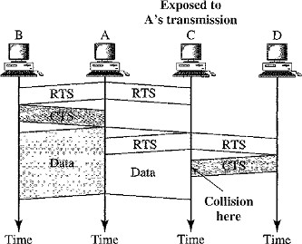
The Handshaking messages RTS and CTS cannot help in this case.
  - Station C hears the RTS from A, but does not hear the CTS from B.
  - Station C, after hearing the RTS from A, can wait for a time so that the CTS from B reaches A; it then sends an RTS to D to show that it needs to communicate with D.
  - Both stations B and A may hear this RTS, but station A is in the sending state, not the receiving state. Station B responds with a CTS.

The problem is here.
If station A has started sending its data, station C cannot hear the CTS from station D because of the collision; it cannot send its data to D. It remains exposed until A finishes sending its data

